Capstone_Stage1

Description

Intended User

Features

User Interface Mocks

Screen 1

Screen 2

Key Considerations

How will your app handle data persistence?

Describe any corner cases in the UX.

Describe any libraries you’ll be using and share your reasoning for including them. Next Steps: Required Tasks

Task 1: Project Setup

Task 2: Implement UI for Each Activity and Fragment

Task 3: Your Next Task

Task 4: Your Next Task

Task 5: Your Next Task

MoviesNow

Description

MoviesNow helps you to be find popular movies, Top rated movies, search for movies and you can see the movies which ever you have saved as favourite instantly. You can see about the details of the movie like rating, popularity, trailers etc., . And a cool new feature that you can search for a movie and viewing the details about it. You could like this App when you are a movie lover and need update about the latest movies.

Intended User

MoviesNow is all for the movie lovers of any age.

1

Capstone_Stage1

Features

* Information about popular movies.
* Information about latest highly rated movies.
* Search for you favourite movies.
* Allow user to add favourite movies.
* Detail description about a movie.
* Movies rating, stars, popularity, etc.

2

**Screen 1**

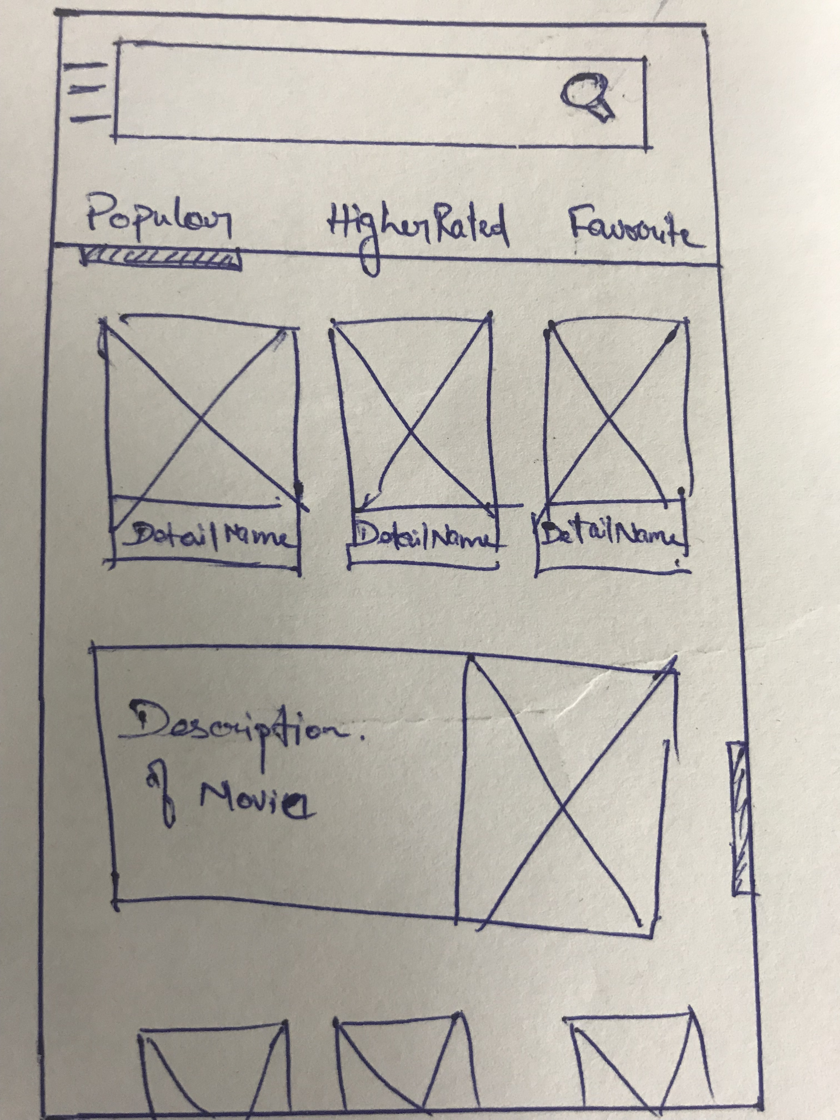

This screen shows the main screen, where the user can understand all options of filter movies (Popular, Top Rated and Favourites added). Swiping the screen left or right where user can change the option that user wants. User can scroll the screen to fing more movies in the list.

3

Capstone_Stage1

**Screen 2**

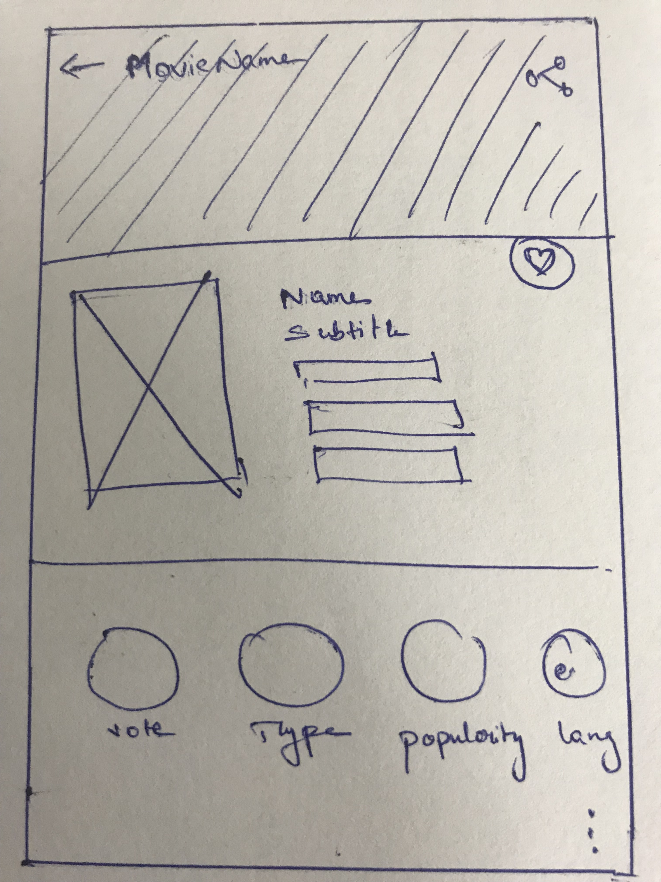

This screen shows about the details of the movie.It shows the each and every details like Vote, type, popularity and language of that movie and even user can add it as favourite but clicking the heart button.

4

Capstone_Stage1

**Screen 3**

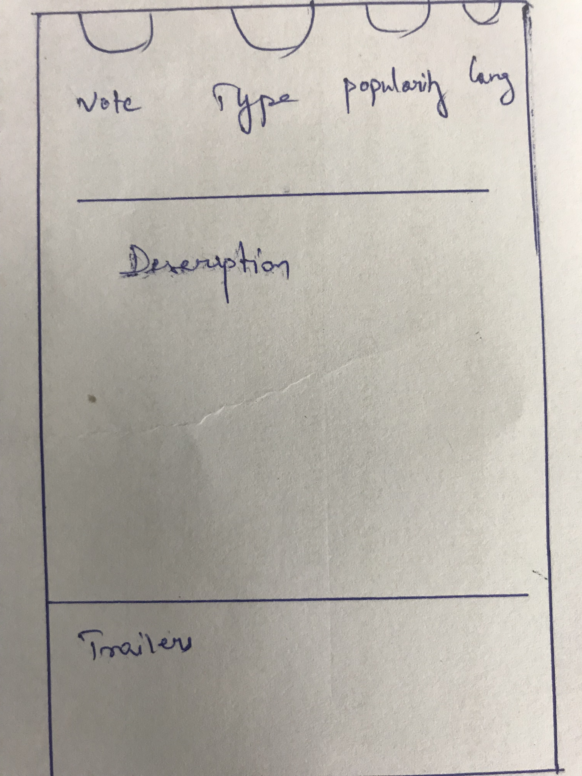

On scrolling down the about screen user can see the decsription of that particular movie, on scrolling more user can see the trailers and the comments for the particular movie.

5

Capstone_Stage1

**Screen 4**

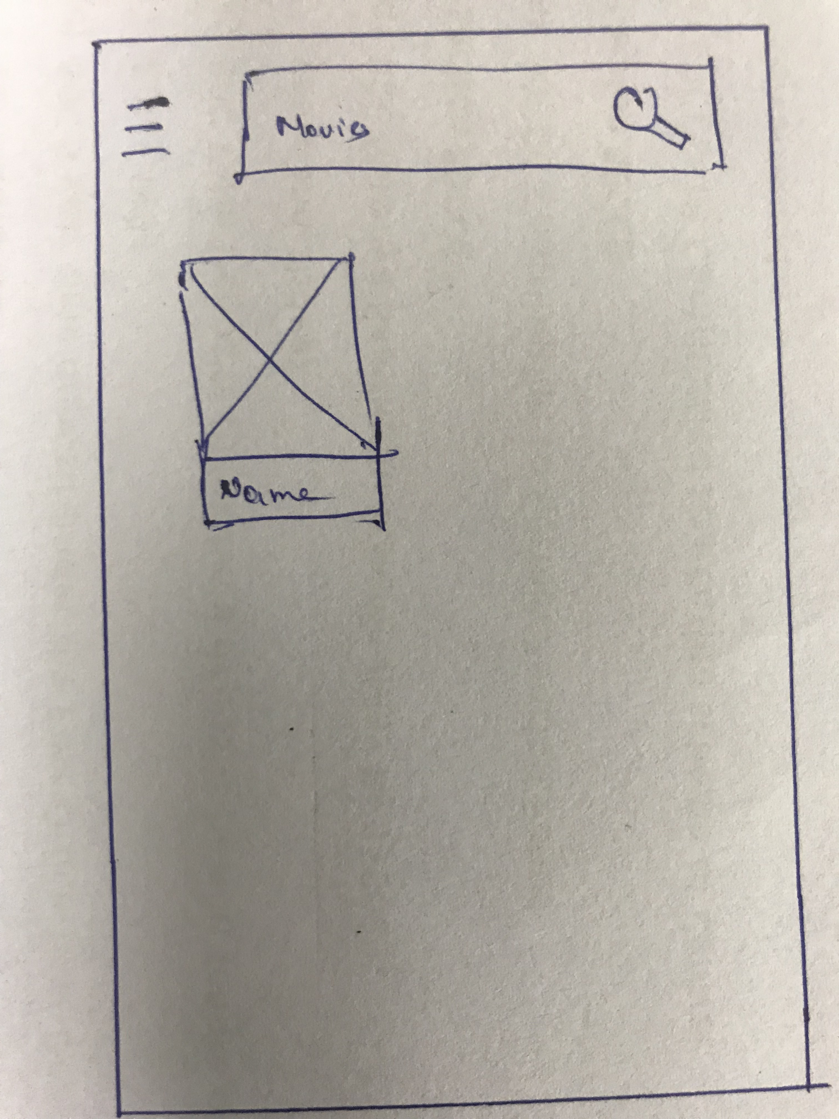

This screen shows a result of a search for movie The user can inform a movie’s name and the app will find with that match at least approximately with the name informed. The result is grouped by “movie and the user has the possibility to click in one of the result to get more information.

6

Capstone_Stage1

**Screen 4**

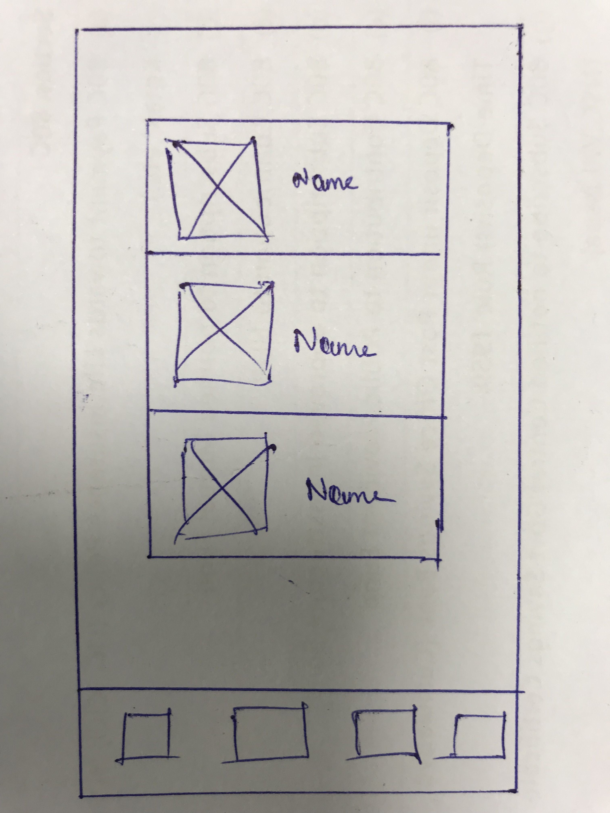

This is the screen for the App widget. The widget consist of the list of the movies which he has added as favourites.

7

Capstone_Stage1

Key Considerations

Below table represent the SDK and libraries which I use developing the app,

All informations about movies are get from ​[TheMovieDB API](https://www.themoviedb.org/)​.Classifications of movies and movies that the user has interest to watch are saved in a local database.

|  |  |
| --- | --- |
| JAVA | 8 |
| Android Studio | 3.3.2 |
| Gradle | 3.3.2 |
| balysv:material-ripple | 1.0.2 |
| mcxiaoke.volley | 1.0.19 |
| android.support:palette | 28.0.0 |
| lapism:searchview | 27.1.1.0.0 |
| recyclerview | 28.0.0 |
| Play-service-ads | 17.2.0 |
| Play-service-analytics | 10.2.4 |

Below are the Android API used in the App,

1. SQLite DB – For storing the favourite movies list.
2. JSONObjectRequest - To getJSON data from movie api in the background.
3. String.xml - Contains all the strings used in the App.
4. Dimension.xml – Contains all the dimensions and sizes.
5. App enables RTL layout switching on all layouts.
6. Content Description – Accessibility for each graphical views.

Next Steps: Required Tasks

**Task 1: Project Setup**

Setup project on Android Studio, configura library and start to manage the tasks.

* Create and configure project on Android Studio.
* Set internal libraries on Gradle.
* Generate API key for movieDB.

**Task 2: Main Screen**

* Implement popular movies, Higher rated and favourite movies.
* Implement the movies in the card view.
* Implement pupular movie, higher rated from movieDB api.

8

Capstone_Stage1

**Task 3: Movie Details**

* Implement the Screen with General Informations about the Movie.
* Implement the Screen to Watch Trailers and Teasers.
* Implement the Screen with Reviews about the Movie.
* Implement favourite button which adds to DB.

**Task 4: Search**

* Implement the Search bar in main screen.

**Task 5: App widget**

* Implement the App widget in the home screen which show the list of favourite movies from DB which user has added.
* IntentService – For loading the widgets.

9